## Introduction

The one handed modification for the Xbox Series X|S Controller are modifications to allow users to operate an Xbox Series X|S controller with one hand. There are modifications for the right and left hands.

## Features

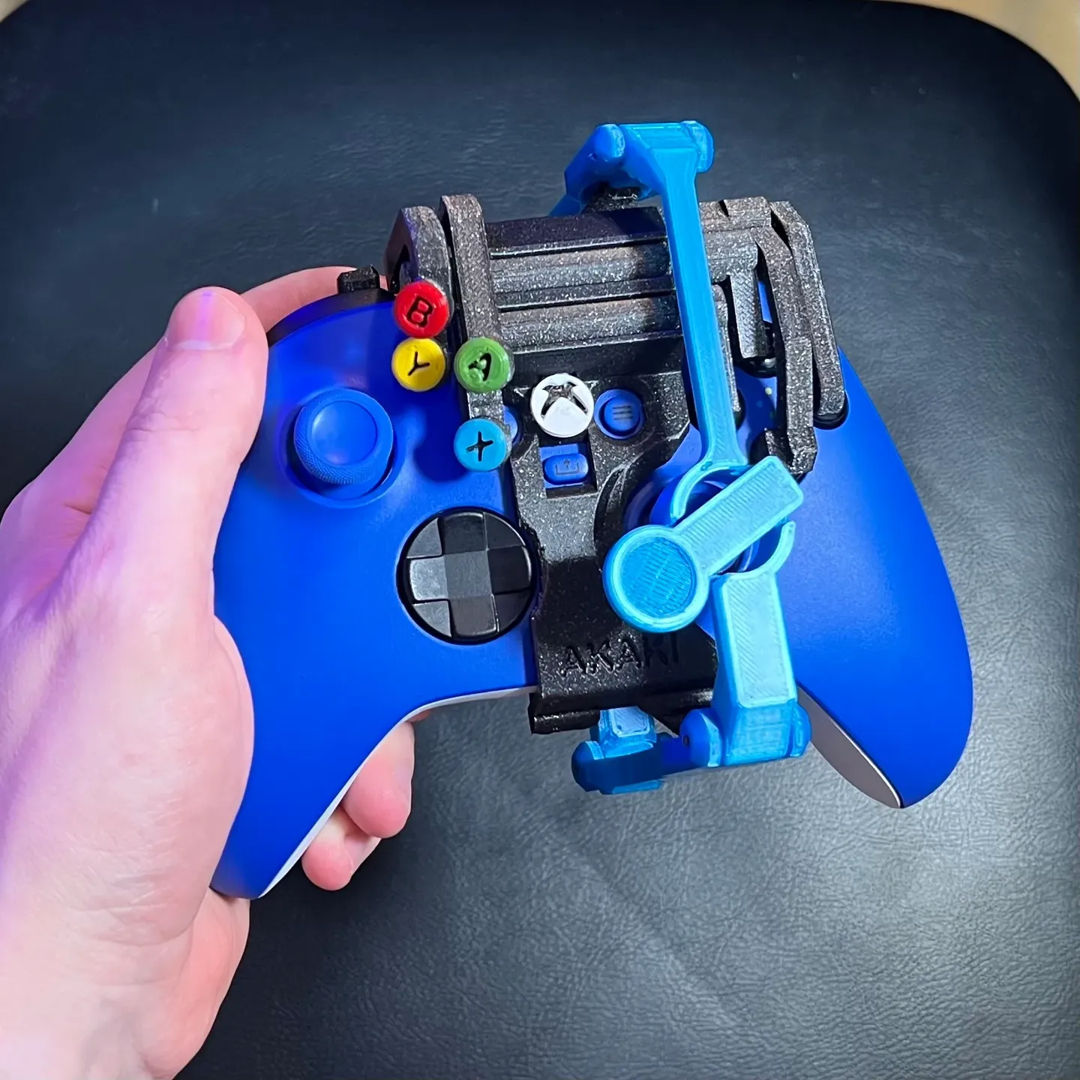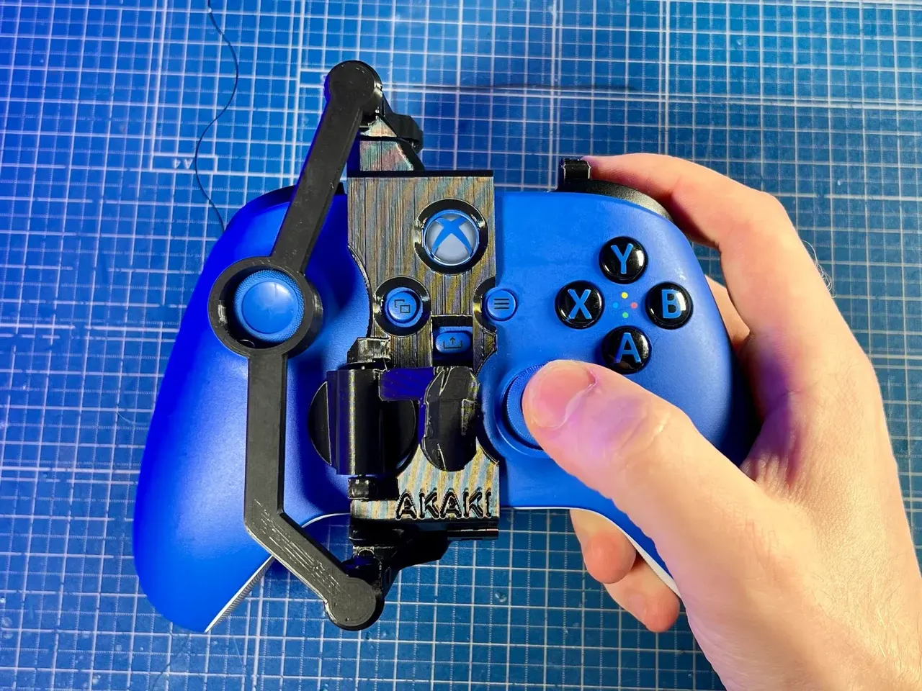

## Usage

To attach the controller modification to the Xbox Series X|S controller, undo the ball joins on the thumb-stick mover armature. Slide the mount onto the controller, starting at the bottom edge. Clip the mount entirely onto the controller; there should be an audible “click”, the mount should sit flush to the top of the controller, and it should be quite snug. If using the leg strap, strap the controller to your leg with the hook and loop fastener. If using the “shoe”, place the controller on your preferred surface. The modifications do not change the functionality of the Xbox controller; they allow the controller to be used with one hand.

## Compatibility

Note that the Xbox controllers can be used on PC based gaming and can be used with a Nintendo Switch with the correct adapter.

**Platforms:** Xbox Series X|S, Xbox One, PC, Nintendo Switch (with an adapter such as the one linked [here](https://www.amazon.ca/Mayflash-Magic-NS-Wireless-Controller-Nintendo/dp/B079B5KHWQ/ref=asc_df_B079B5KHWQ/?tag=googleshopc0c-20&linkCode=df0&hvadid=292937839648&hvpos=&hvnetw=g&hvrand=11899347943701197930&hvpone=&hvptwo=&hvqmt=&hvdev=c&hvdvcmdl=&hvlocint=&hvlocphy=9000712&hvtargid=pla-487335326322&psc=1)).

**Controllers:**[Xbox Series X|S Controllers](https://www.microsoft.com/en-ca/d/xbox-wireless-controller/8xn59crbsqgz)

## Specifications

Right handed modification:

*Dimensions:* 9.5 x 12 x 10 cm

*Weight:* 64 g

Left handed modifications:

*Dimensions:* 11.5 x 12 x 12 cm

*Weight:* 78 g

## Cleaning

The modifications can be disassembled and the pieces wiped clean with standard cleaners that do not destroy plastics.